“BIDIRECTIONAL VISITORS COUNTER”
PROJECT REPORT

BACHELOR OF ENGINEERING
In
Electronics & Telecommunication
By
1.Vaishnavi Dhumal 111/18
2.Rutuja Gaikwad 248/18
3.Manisha Gambhire 256/19


Under the Guidance of
(Prof. K.G. Jagtap)

DEPARTMENT OF ELECTRONICS AND TELECOMMUNICATION SHIVNAGAR VIDYA PRASARAK MANDAL

College of Engineering
Malegaon(BK)- 413 115 of
SAVITRIBAI PHULE PUNE UNIVERSITY Academic Year: 2020-2021

CERTIFICATE

This is to certify that

1.Vaishnavi Dhumal 111/18
2.Rutuja Gaikwad 248/18
3.Manisha Gambhire 256/19

have satisfactorily submitted the mini-Project report titled

“BIDRECIONAL VISITORS COUNTER”

in partial fulfilment of third year of Engineering in

Electronics & Telecommunication

At
College of Engineering, Malegaon (Bk)

SAVITRIBAI PHULE PUNE UNIVERSITY (2020-21)
Prof./Dr.K.G.Jagtap | Dr.A.A.Patil | Dr.S.M.Mukane
Internal Guide | H.O.D | Principal

ACKNOWLEDGMENT

It is our proud privilege and duty to acknowledge the kind of help and guidance received from several people in preparation of this report. It would not have been possible to prepare this report in this form without their valuable help cooperation and guidance.

We would like to express our sincere gratitude to our guide (Prof./Dr. K.G.Jagtap), for his patience and guidance along the semester for an investigation of this project and in carrying out experimental work.

Our sincere thanks to Dr.A.A.Patil Head of Department of Electronics and Telecommunication Engineering, for his valuable suggestions and guidance throughout the period of this semester.

We wish to record our sincere gratitude to our Principal Dr.S.M.Mukane for his constant support and encouragement in preparation of this report and for making available library and laboratory facilities needed to prepare this report.

Finally, I would like to wish special thanks to Management of SVPM’s College of Engineering, Malegaon (Bk.), all staff members, my family members and friends, without whose patience, encouragement, and support this Project work might never have been completed.

Vaishnavi Dhumal
Rutuja Gaikwad
Manisha Gambhire
Table of Contents

Chapter | Topic | Page Number
 | Abstract
1. | Introduction
2. | Literature Review/Survey
3. | Problem Statement
4. | Proposed system
5. | Block Diagram & Description
6. | Design & selection of components
7. | Circuit Diagram
8. | Algorithm & Flow Chart
9. | Results
10. | Advantages
11. | Application
12. | Conclusion
13. | Future Scope
 | References

ABSTRACT

Visitor counting is simply a measurement of the visitor traffic entering and exiting offices, malls, sports venues, etc. Counting the visitors helps to maximize the efficiency and effectiveness of employees, floor area and sales potential of an organization. Visitor counting is not limited to the entry/exit point of a company but has a wide range of applications that provide information to management on the volume and flow of people throughout a location. A primary method for counting the visitors involves hiring human auditors to stand and manually tally the number of visitors who pass by a certain location. But human-based data collection comes at great expense.
This thesis is based on the design of a bi-directional visitor counter using the microcontroller. The main concept behind this project is to measure and display the number of persons entering in any room like seminar hall, conference room. LCD display placed outside the room displays number of persons inside the room. This project can be used to count and display the number of visitors entering inside any conference room or seminar hall. This works in a two way. That means counter will be incremented if person enters the room and will be decremented if a person leaves the room.

Applications of these systems are essential in various rooms like seminar hall, where the capacity of room is limited and should not be exceeded. The system will display the actual number of persons inside the room and future improvement to the system include adding a voice alarm system to indicate when the room is full and people can no longer enter inside.

Introduction

Many times we need to monitor the person/people visiting some place like Seminar hall, conference room or Shopping mall or temple. This project can be used to count and display the number of visitors entering inside any conference room or seminar hall. This is bidirectional counter which means it works in a two way. That means counter will be incremented if person enters the room and will be decremented a person leaves the room. LCD displays this value which is placed outside the room. This system is helpful for counting the number of people in an auditorium or halls for seminar to avoid congestion.

Moreover, it can also be used to check the number of people who have come to an event or a museum to watch a certain exhibit. Microcontroller is a reliable circuit that takes over the task of counting the number of persons/ visitors in the room very accurately. We will be showing both the in count i.e. number of people entering the room and out count i.e. number of people exiting the room on a16x2 Alphanumeric LCD.

An IR sensor issued to monitor the person entering and exiting the room. The microcontroller does the above job. I receive the signals from the sensors and this signal is operated under the control software which is stored in ROM. Microcontroller 89s52 continuously monitor the Infrared Receivers. When any object passes through the IR Receiver’s then the IR Rays falling on the receiver are obstructed, this obstruction is sensed by the Microcontroller.

Literature Review/Survey

In recent times, the number of visitors to protected and recreational areas has almost doubled during the past ten years throughout the whole world (Horne et al., 1998). Now it is estimated that about five hundred million visits are made annually to national parks and other recreational areas. These assumptions based on different ways of estimating the number of visits. Earlier, the estimates were based on trial logs, examination of footprints and deterioration of the trails, various permits and best estimates made by personnel working in the areas. However, the lack of uniformity in the world countries development and consequently the lack of uniformity in data keeping practices have made it difficult to estimate correctly the number of visitors to places designated as public in the individual countries and the world at large. This makes reliable visitor counting not only difficult, but at the same time extremely challenging.

During the past two years, appreciable efforts have begun to count visitors to public areas more systematically and consistently. Some counters were already in use in the mid-1990s, but insufficient use was made of them. More accurate estimation of the number of visitors was made considerably easier by the publication of a manual on visitor counting in Finnish (Horne et al., 1998), which has been widely applied in practice. Other good manuals on visitor counting have been published, for example, in Scotland and the United States (e.g. Dales et al., 1993 and Yuan et al., 1995). The problem has been and still is to some extent the lack of systematic and sufficiently reliable visitor statistics.

Reliable estimates of the number of visitors are extremely important for planning and managing the use of the areas in question. On the basis of such estimates, it is possible to gain clearer picture of the use of the area and the sites where visitor traffic is heaviest. Information on visitor numbers help the people responsible for managing the areas to control the flow of visitors, for example, by directing them to routes that causeless deterioration to vegetation and landscape. In addition, visitor counts also help to maintain and develop services so that they better correspond to the real number of visitors to the area (e.g. firewood supply and waste disposal).

Furthermore, reliable visitor statistics are needed, together with other information gathered from visitor surveys, for evaluating the effectiveness of the area’s own activities and for monitoring changes.

Visitor counting involves the following distinct stages:
- Careful planning of the visitor count
- Installation of counters in the terrain
- Monitoring of counters in the terrain
- Defining the correction coefficient for the counters
- Counting the number of visits

Visitor counting thus provides statistics on the number of actual visits that have been made to an area. When this information is combined within formation gained from visitor surveys, it is possible to estimate the number of visitors, i.e. how many people visit the area. In a public place such as shopping malls, religious centres and cinemas, data on the number of visitors is frequently needed for marketing research or statistic purposes. Usually, the counting process is done manually by the officers who guard the entrance. If this process is done for a long period of time, it will be prone to human errors.

Same goes to a room such as laboratory, main hall, mosque or bedroom. With the advent of industrial and business era in Nigeria and the subsequent establishment of many public areas such as churches, shopping malls, recreational centres and so on, there is a need to make adequate preparation and plans for visitor control and management. This will help to keep accurate information on population density per time, identify potential structural and social risks and effective decision making on issues related to population.

Problem Statement
Background reading revealed that the technology of visitor counting had dated back to the 1990s. However, there are some shortcomings present in the existing system. Visitor counting is simply a measurement of the visitor traffic entering and exiting offices, malls, sports venues, etc. Counting the visitors helps to maximize the efficiency and effectiveness of employees, floor area and sales potential of an organization. Visitor counting is not limited to the entry/exit point of a company but has a wide range of applications that provide information to management on the volume and flow of people throughout a location.

However, a primary method for counting the visitors involves hiring human auditors to stand and manually tally the number of visitors who pass by a certain location. But human-based data collection comes at great expense. With human handling the manual counting of visitors, there are tendencies of inefficiencies, misrepresentation, time wastage and unnecessary financial implications. With this in mind, it is imperative to develop and promote a digital visitor counter which will be bidirectional in nature and utilise the microcontroller. This will limit all human interferences to the barest and ensure that the task of keeping data on visitors’ visit is less time-consuming, efficient and almost error free.

A counter system can be design in many ways such as combination of gate logic and microcontroller. Gate logic is simple and easy but this feature is difficult to vary and becomes complex if the system needs more improvement in requirements. But, by the using of a microcontroller, a system can be more complex but easy to design. This system will be designed on a smaller scale to model the actual system. The model will function exactly as the actual system will. A sensor will be used to detect a person enter and out from the door and send signal to microcontroller. This microcontroller will count up and down based on the programming that been embedded on the PIC. An LCD display will inform the total occupant inside the laboratory and at the same time will display the counting data when a person enters or leave the room.
Proposed system

This system, the traffic or agents or human follow a certain route or door or some threshold to enter into and to exit from the place. While entering to the system, there are two sensors are installed which are connected with each other via infrared network. While a visitor crosses the infrared bar or line, it is disconnected and at that time Microcontroller increase its count by one. When someone crosses the bar in opposite direction, the infrared line is again interrupted and then Microcontroller decreases its count by one to signify that one visitor is entered and one is gate away from the place.

Block Diagram & Description

Fig-1
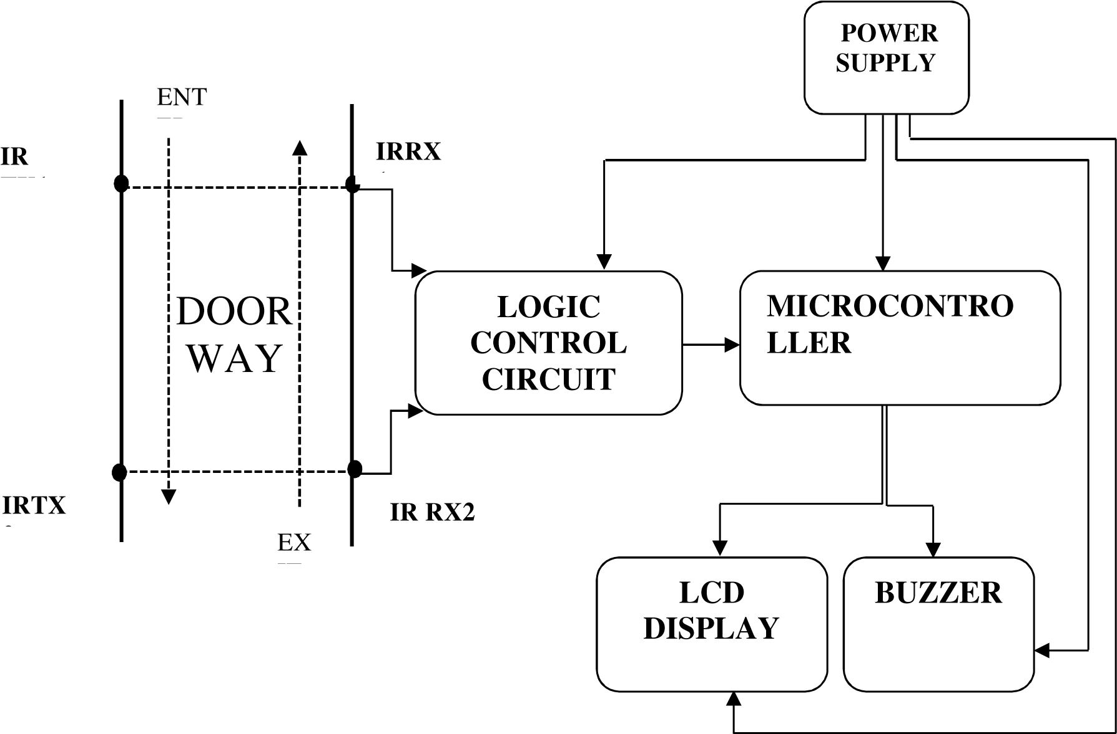
SPECIFICATIONS
Table-1
1 | Microcontroller | 1 | PIC16F877A
2 | Crystal oscillator | 1 | 5MHZ
3 | Liquid Crystal Display (LCD) | 1 | 16x2
4 | Infrared sensor | 2 pair | TSAL6100
5 | Buzzer | 1 | 70dB, at 2kHz, 5V
6 | Resistor | 12 | 1k,100k,270k
7 | Variable Resistor | 1 | 4.7k,50k
8 | Transistor | 3 | BC546,BC557
9  10  11  12  13  14  15  16 | Voltage Regulator  Transformer  Fuse  Diode  Main switch  Light Emitting Diode (LED)  Reset Button  Vero Board | 1  1  1  6  1  5  1  2 | 7805  240/6v  IN4007  5mm  Small Size

Design & selection of components

Sensor Section -

This comprises the IR sensor which consists of a transmitter (white LED) and a receiver (black LED). The emitter passes an infrared beam which is detected by an IR receiver (phototransistor). When a person walks by, he "breaks" the beam. Upon this event, the phototransistor no longer can detect infrared light and another event is triggered (door opens). The infrared emitter generates a source of light energy (invisible) in the infrared spectrum. There are several sensors that may be used for the detection of visitor’s presence, but the preferred one used in this project is the infrared sensor. The infrared sensor also called IR sensors consists of two parts, namely, IR transmitter circuit and IR receiver unit. The transmitter unit consists of an infrared LED and its associated circuitry as well as the receiver.
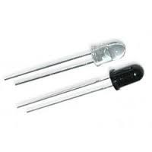
Fig-2 Infrared Sensor (Transmitter and Receiver)

Since the human eye cannot see the infrared radiations, it is not possible for a person to identify whether the IR LED is working or not, unlike a common LED. To overcome this problem, the camera on a cell phone can be used. The camera can show us the IR rays being emanated from the IR LED in a circuit. To test if the sensors were functioning, the sensor circuit was connected to a power source. The circuit was built with 2 resistors with different Ohm value ratings. A 1kΩ resistor connected to a Light Emitting Diode (LED) served as the transmitter whereas a 3kΩ resistor connected to a transistor was used as the Receiver. The circuit is then powered by a 5V DC supply and grounded.

Microcontroller Section -
The microcontroller section consists of the PIC16F877A Microcontroller which is a powerful (200 nanosecond instruction execution) easy-to-program (only 35 single word instructions) CMOS FLASH-based 8-bit microcontroller packs Microchip's powerful PIC architecture into a 40-pin package and is upwards compatible with the PIC12CXXX and PIC16C7X devices. The PIC16F877A features 256 bytes of EEPROM data memory, self-programming, an ICD, 2 Comparators, 8 channels of 10-bit Analog-to-Digital (A/D) converter. It has a voltage operating range of 2v to 5.5v, with a temperature range of -40°C to 85°C. [1].

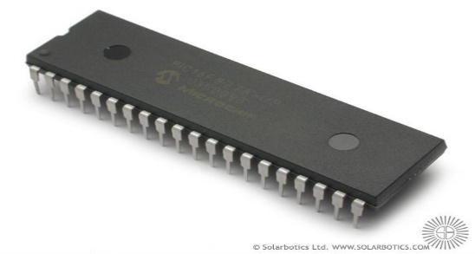

Fig-3 Pictorial view of a PIC16F877A microcontroller

There are three basic memory blocks in the PIC16F877 namely; the Read Only Memory (ROM), the Data Memory also called the random-access memory (RAM), the Electrically Erasable Programmable Read Only Memory, (EEPROM), and the data memory. The Program Memory (ROM) is used to permanently save the program being executed. The PIC16F877 has 8 kb of ROM (in total of 8192 locations). Since this ROM is made with FLASH technology.

Fig-4

`1The PIC16F877 EEPROM has 256 bytes of memory locations for permanently saving results obtained and used during its operation. The EEPROM as the name suggests is a type of ROM which contents may be changed during program execution (similar to RAM), but remains permanently saved even after the loss of power (similar to ROM). It is often used to store values created and used during operation (such as calibration values, codes, values to count up to, etc.), which must be saved after turning the power supply off.
The RAM is the third and the most complex part of any microcontroller memory. It is partitioned into multiple banks which contain the general-purpose registers (GPRs) and special-function registers (SFRs). These registers are basically used for temporarily storing data and intermediate results created and used during the operation of the microcontroller. The content of this memory is cleared once the power supply is off [13].
The Central Processing Unit (CPU) monitors and controls all processes within the microcontroller and the user cannot affect its work. The PIC16F877 CPU consists of several smaller sub-units, of which the most important are Instruction Decoder, Arithmetic Logic Unit (ALU) and Accumulator (or Working Register). The Instruction Decoder is a part of the electronics which recognizes program instructions and runs other circuits on the basis of that. Whilst the ALU performs all mathematical and logical operations upon data, the Accumulator or Working Register is an SFR closely related to the operation of ALU. It is a kind of working desk used for storing all data upon which some operations should be executed.
The PIC16F877 has a 10-bit multi-channel Analog-to-Digital Converter. Apart from a large number of digital I/O lines, the PIC16F877 contains 14 analog inputs. They enable the microcontroller to recognize, not only whether a pin is driven to logic zero or one (0 or +5V), but to precisely measure its voltage and convert it into a numerical value, i.e. digital format. PIC16F877 has a total of thirty-three input/output pins. The pins can be organized into five ports; A, B, C, D and E. Some pins for these input/output ports are multiplexed with an alternate function for peripheral features on the microcontroller. Port A is 6-bit wide and bidirectional; Ports B and C are 8-bit wide and bidirectional; Port D is also 8-bit wide with Schmitt Trigger input buffers. Port D can also be configured as an 8-bit microprocessor port (parallel slave port). Port E is just 3-bit wide and also bidirectional. The Bidirectional Visitor Counter requires only port A and B on the microcontroller to send and receive signal for the counting operation.
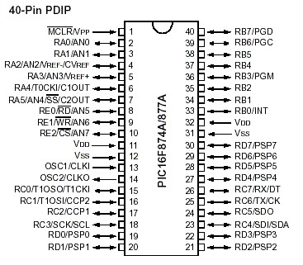
Fig-5 Illustration of the 40 pins arrangement on the microcontroller.

The pin diagram of the PIC that was used in this project. With V_{ss} or V_{dd} being the input voltage signals connected to a 5v DC supply unit. The remaining pins indicate the general purpose I/O peripheral ports that include the Digital I/O, the In-circuit debugger, the ICSP programming clock (PCG) and the ICSP programming data (PCD).These will operate according to the set of instructions meted out by the programmer.
Pin description used for the bidirectional visitor counter
Table-2

RESONATOR (Crystal Oscillator)-

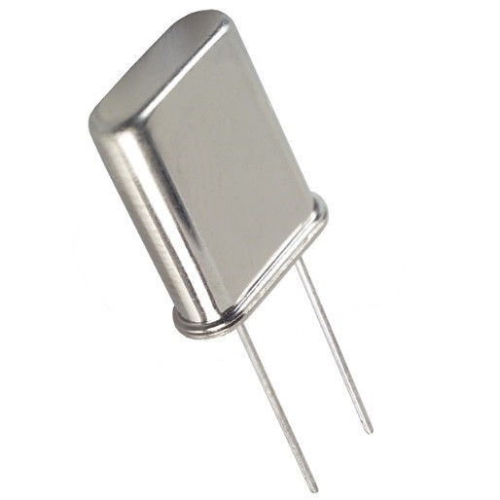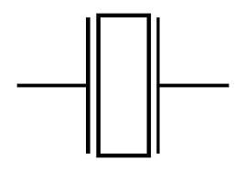

Figure 5: crystal oscillator Figure6 : crystal oscillator symbol
A crystal oscillator is an electronic oscillator circuit that uses the mechanical resonance of a vibrating crystal of piezoelectric material to create an electrical signal with a very precise frequency. This frequency determines how fast a microcontroller executes its instruction. It serves as the heartbeat of the microcontroller.

Crystal oscillator is kept in metal housing with two pins where the frequency at which crystal oscillates. One ceramic capacitor whose other end is connected to the ground needs to be connected with each pin. Oscillator and capacitors are packed in joint case with three pins. Such element is called ceramic resonator. The center pins of the element are the ground, while end pins are connected with OSC1 and OSC2 pins on the microcontroller. When designing a device, the rule was to place an oscillator nearer a controller, so as to avoid any interference on lines on which microcontroller is receiving a clock [7].
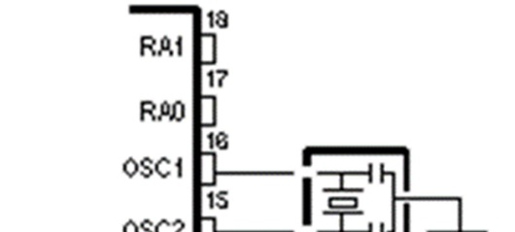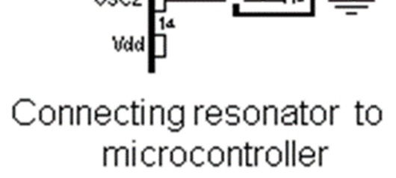
Figure7: Illustration of an oscillator to a microcontroller
Alert Section –
LCD screen is an electronic display module with a wide range of applications. A 16x2 LCD means it can display 16 characters per line and there are 2 such lines. In this LCD each character is displayed in 5x7 pixel matrix. This LCD has two registers, namely, Command and Data. The command register stores the command instructions given to the LCD.
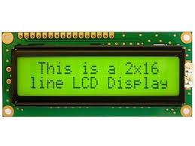
Figure8: Pictorial view of the LCD
A command is an instruction given to LCD to do a predefined task like initializing it, clearing its screen, setting the cursor position, controlling display etc. The data register stores the data to be displayed on the LCD.

The LCD screen displays the present the exact number of visitors in a building, and operates in 4-bit 'nibble' mode to save I/O pins. For this project, the LCD is connected directly to Port B of the microcontroller. A 50 kΩ potentiometer is connected to pin 2 of the LCD for adjusting the contrast of the display. The LCD screen will display “Capacity Full” when the microcontroller detects that the required number of visitors supposed to occupy a particular building is exceeded.

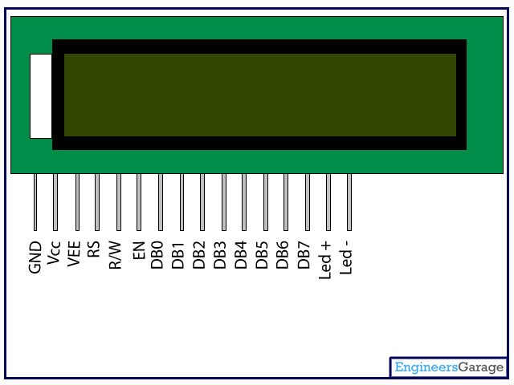
Figure9: schematic view of an LCD screen

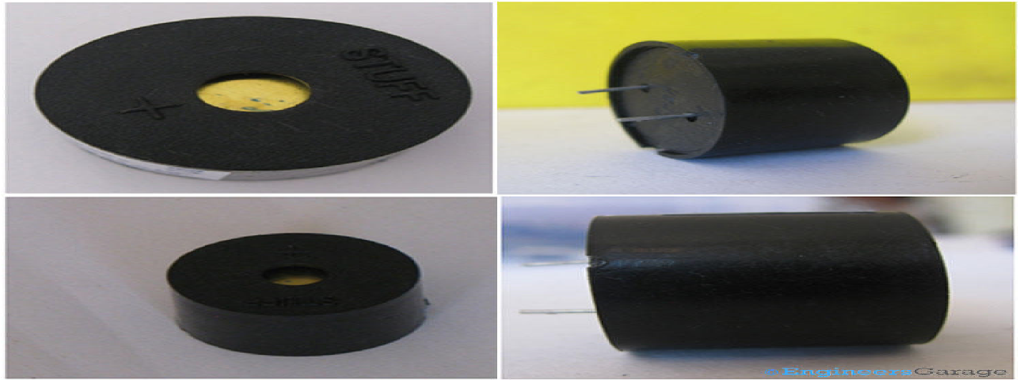

Figure10: Transducer (buzzer)

Table 3: LCD pin description
Pin No | Function | Name
1 | Ground (0V) | Ground
2 | Supply voltage; 5V (4.7V – 5.3V) | Vcc
3 | Contrast adjustment; through a variable resistor | V_{EE}
4 | Selects command register when low; and data register when high | Register Select (RS)
5 | Low to write to the register; High to read from the register | Read/write (RW)
6 | Sends data to data pins when a high to low pulse is given | Enable (E)
7 | 8-bit data pins(Data bus line-DB) | DB0
8 |  | DB1
9 |  | DB2
10 |  | DB3
11 |  | DB4
12 |  | DB5
13 |  | DB6
14 |  | DB7
15 | Backlight V_{CC} (5V) | Led+
16 | Backlight Ground (0V) | Led-

The piezo buzzer is a device or a transducer which converts electrical energy to sound energy. When electrical energy is applied to it, it buzzes or sounds until the energy applied to it is stopped. The buzzer used in this project alert user of the event corresponding to capacity changes by producing a noisy sound irrespective of the voltage variation applied to it. The buzzer has two terminals (positive and ground).

Power Supply –

Power supply block consists of following units: Step down transformer; Bridge Rectifier Circuit, Input Filter and Voltage Regulator.
The step-down transformer is used to step down the supply voltage of 240v ac from mains to lower values such as 6v and 9v, as the various IC’s used in this project require reduced voltages.
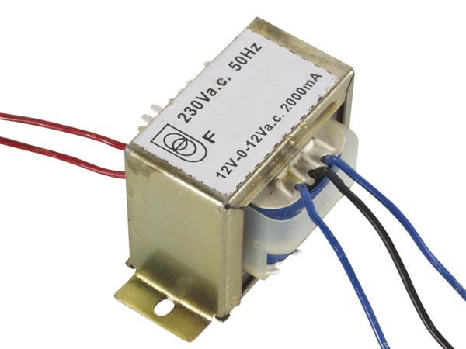
Figure11: Pictorial view of step-down transformer
The Rectifier Unit is purposely for alternating current (AC) to direct current (DC) conversion. A diode bridge is an arrangement of four diodes connected in a bridge circuit. That provides the polarity of output voltage of any polarity of the input voltage. The diagram describes a diode-bridge design known as a full wave rectifier. The bridge rectifier makes use of four diodes in a bridge arrangement to achieve full wave rectification.

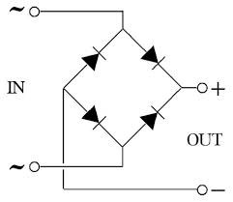
Figure12: bridge rectifier circuit
In the Input Filter, capacitors are used as filters. The ripples from the dc voltages are removed and pure dc voltage is obtained. The primary action performed by capacitor is charging and discharging. It charges in positive half cycle of the ac voltage and it will discharge in negative half cycle. This filter is fixed before the regulator. Capacitors used here are of the value 2200uF . The Voltage regulator unit regulates the output voltage to a specific value. The output voltage is maintained irrespective of the fluctuations in the input dc voltage. Whenever there are any ac voltage fluctuations, the dc voltage also changes, and to avoid these regulators.

Figure13: Pictorial view of a voltage regulator

The KA78XX/KA78XXA is a series of voltage regulators made up of three-terminals, namely input, output, and ground. The type of voltage regulator used in this application is a KA7805 which provides 5v dc as output voltage for the entire circuit.

Circuit Diagram
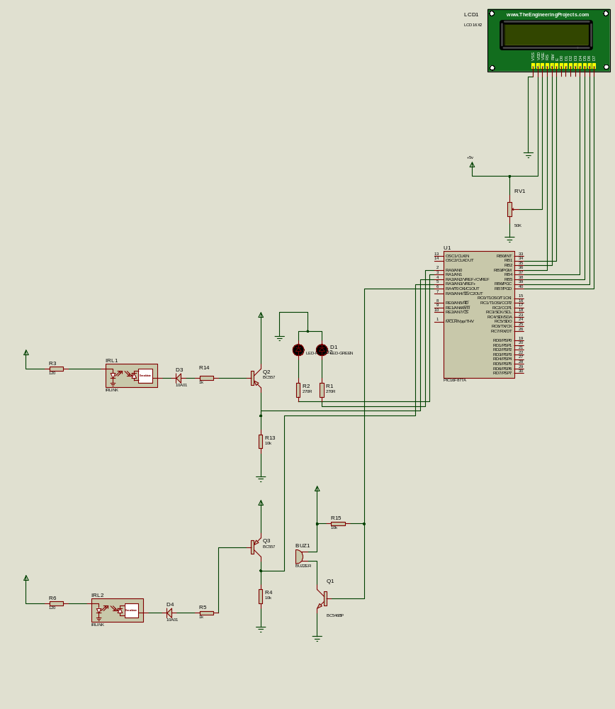

Algorithm & Flow Chart

YES
YES
If s2
is

NO
YES
If
No :
>10

Display “MAXIMUM
CAPACITY EXCEEDED
BY: XXX” and beep
buzzer

Update LCD
YES
NO
NO
NO
Take no
action
Start

Clear LCD
I
f s1
is

I
f s2
is

If s

1
is

On Red LED
Decrement count
YES
NO
On

Green LED

Increment count
Results

This chapter projects the analysis and discussion of results and findings during and after the implementation of design. It describes in detail the final design perspective as well as highlighting the probable defects engulfing the project. A preview to the entirety of this project establishes the essence and need for embedded systems towards technological advancement. The diagram in represents the block diagram of the bidirectional visitor counter. This project incorporates the following; a PIC 16F877A microcontroller, IR sensors, transistors, resistors, diodes, LEDs, LCD, and a buzzer. The block diagram gives a preview as to what the project entails.

The 2-pair of infrared (IR) which consist of a transmitter (TX) and a receiver (RX) is mounted face to face across the doorway. Both sensors are positioned at the entrance with distance apart. This means upon the approach of a visitor the installed 2-pair sensors are triggered by the obstruction. The direction of the visitor is determined by which sensor is obstructed first before the other sensor follows. If sensor 1 is interrupted first before sensor 2 is interrupted, it indicates that the visitor is entering. The visitor exits the premises by interrupting the sensor in opposite direction.

The output of the receiver circuit sends high or low signals in a form of voltage to the microcontroller. The programmed microcontroller follows the set of instructions (C language) written on it. The tally computation (addition and subtraction) is done when it receives low signals from the two IR receivers. It is after this command, which the microcontroller is made to send control signals to the other I/O devices. The
microcontroller also sends a data signal to the LCD to visually display the exact number of visitors remaining in the building. The buzzer is activated when the microcontroller detects that the room capacity is exceeded.

Advantages

Shopping malls, marketing professionals and recently, religious and academic gatherings rely on visitor statistic to measure their organizational progress in terms of population (patronization), make effective managerial and operational decisions and optimization of opportunities e.g. applying for financial aids etc. Over time, different counting procedures and counters have been employed, among which are beam counters, thermal counter, video counting etc. However, most of these counting systems are archaic, cannot meet up with the current demand for faster and more accurate statistics on visitors. Majorly, most counting procedures depends on human for over 70% operations thus introducing a sizable number of errors arising from different procedural inefficiencies.

In view of these and many more, the need for a digital visitor counter which is bi-directional is imperative as this will alleviate the challenges of human unnecessary interferences with visitors’ statistics, save time and money and at the same time giving an efficient output which can be relied upon in any circumstances except for system malfunctions.

Application

This system can be well used in market place or in some closed place like voting are or poll section. This device can be securely used with hiding the sensors also. So, the secret counting may be obtained. It can be used for counting the numbers of traffic if it will be installed on the road or highway, but in that case the sensitivity must be much higher than that of the household or small market place application

Conclusion

We conclude and make recommendations in this section based on our results.
We re-iterate the following as noted from our discussions of the results in the above section:
- In demonstration of the project, the infrared sensing part used to detect the passage of visitors worked
- Microcontroller was very efficient in its task performance, thus computation of counts and controlling I/O devices
- Also, the LCD, led and the buzzer were effective in alerting and notifications.
- Hence the whole purpose of the bidirectional visitor counter was successfully achieved and is applicable in the wider scope.
Finally, we conclude that the proposed system will count visitors effectively and efficiently by reducing the rate at which error occurs when counting visitors
We are convinced, from the above results, that the bidirectional visitor counter is highly efficient and economical. There is no time lag in the operation of the system. The system offers most favorable operation since it functions continuously without errors. Its program can also be modified to take additional input depending on the function desired by the designer. There is no need for human auditor services.

Future Scope

This project primarily base on modelling of a micro-controller controlled bi-directional visitor counter system that will:
- Count visitor which enters and leave the room and display total occupant inside the room
- Implement two IR proximity sensors
- Identify the counter process (count up or countdown)
- Work in a single entrance and single exit room
References

- 40 PIN 8-bit CMOS Flash Microcontroller. (n. d.). Retrieved from http://www.mantec.be/en/pic-s/2722040pin-8-bit-cmos-flash-microcontroller-5410329355951.html .
- Architecture and Programming of 8050 MCU’S. (n. d.). Retrieved from http://www.mikroe.com/chapters/view/64/chapter-1-introduction-to-microcontrollers/ .
[3]Banuchandar, J., Kaliraj, J., Balasubramanian, P., Deepa, S. & Thamilarasi, N. (2012). Automated Unmanned Railway Level Crossing System, IJMER 2 (1): 458-463.
- Subiakto, E.C(2009) Digital Tally Counter Finger Ring. Retrieved from http://www.google.com/patents/WO2009144689A1?cl=en .
- FitzGerald, J. & Eason, T.S. (1978). Fundamentals of Data Communications. New York: John Wiley & Sons.
- Heath, S. (2003), Embedded systems design, Second Edition, Burlington: Newnes.
- How to Earn Money Easily: Study tools Operating Details of Selecting Electronics and Non-electronic
Software’s. Famous Personalities. Science Knowledge. Stories. (2012). Retrieved from http://softwaremanonlinein.blogspot.com/2012/12/sms-based-banking-security-system.html.
- Infrared Emitter Decoder. (n. d.). Retrieved from www.boondog.com/tutorials/irled/ir.html.
- Kushagra(2012). Digital Signage Players. Retrieved from http://www.engineersgarage.com/electroniccomponents/16x2-lcd-module-datasheet .
- Mehta, V. K., & Mehta, R. (2005), Principles of Electronics, Twenty Third Revised Edition, New Delhi: S. Chand and Company Ltd.
- Micro basic PRO for ds PIC (n. d.) Retrieved from www.microchip.com.
- Microchip: Built- In Intelligence. (n. d.). Retrieved from www.mikroe.com/.../eng/.../introduction_to_mikroc_pro_for_pic.htm.
- Microprocessors, Microcontrollers, Architecture and Programming Concepts. (n. d.). Retrieved from http://www.slideshare.net/ashmus/microproccesor-and-microcontrollers-hardware-basics.
- Murthy, S.R. & Gurusamy, M. (2002). WDM Optical Networks: Concepts, Design, and Algorithms, Prentice Hall PTR.
- Nemzow, M., (1995). Implementing Wireless Networks. New York: McGraw-Hill.
- Nissinen, J., Nissinen, I. & Kostamovaara, J. (2009). Integrated Receiver Including Both Receiver Channel and TDC for a Pulsed Time-of-Flight Laser Rangefinder With cm-Level Accuracy, IEEE, 44(5): 14861497.
- PIC microcontroller. (n. d.). In Wikipedia. Retrieved from http://en.wikipedia.org/wiki/PIC_microcontroller.
- Sensor: Wikis. (n. d.). In Encyclopedia. Retrieved from http://www.thefullwiki.org/Sensor.
- Shenton, C. (2012). The Day Parliament Burned Down, Oxford: Oxford University Press,

